Personal Health Information

Please note: Information provided assists the therapist in providing safe, effective treatment. All information is kept in confidence, except as required by law, and written authorization is required prior to its release.

Personal Data
Name:________________________________________________ Date:____________
Address:______________________________________________ Phone:__________
City:______________________ State:_____________ Zip:____________
Date od Birth:__________________ E-mail address:_____________________________
Occupation_____________________ Referred by:______________________________
Pirmary Care MD:______________________________ Phone:___________________
Permission to consult with MD: Yes_________________ No_________ please initial

Emergency Contact:_____________________________ Phone:_________________

Primary Complaint:_______________________________________________________
Other concerns:__________________________________________________________
Have you received treatment for this issue? If so, what have you received? ________________________________________________________________________________________________________________________________________________

Past Medical History: (please include surgical history) ________________________________________________________________________________________________________________________________________________________________________________________________________________________________________________________________________________________________

Pain diagram: Please indicate where you are experiencing pain or discomfort.
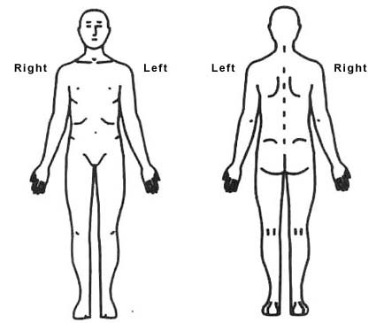

Medications:_____________________________________________________________________________________________________________________________________________________________________________________________________________

Health History

Musculoskeletal Skin
bone or joint disease: _____________________ allergies:______________________
tendinitis:_______________________________ rashes:________________________
bursitis:_________________________________ althlete’s foot__________________
fractures:________________________________ warts:_________________________
surgeries:________________________________ bruise easily:___________________
athritis:_________________________________ other:_________________________
sprains/strains:____________________________
spasms/cramps:___________________________ Digestive
constipation:___________________
Cardio-vascular IBS:__________________________
heart condition:___________________________ other:_________________________
stroke:__________________________________
phlebitis:________________________________ Nervous System
varicose veins:___________________________ herpes/shingles:_________________
high/low blood pressure____________________ numbness/tingling:______________
lymphedema:_____________________________ fatigue:_______________________
other:___________________________________ sleep issues:____________________
other:_________________________
Respiratory
allergies:________________________________ Reproductive
breathing difficulties:______________________ pregnant?:______ due date_______
asthma:_________________________________ PMS:________________________
emphysema:_____________________________ menopause:___________________
bronchitis:_______________________________ other:________________________
sinus issues:______________________________
other:___________________________________

Other conditions

cancer:_________________________________ diabetes______________________
infectious diseases:_______________________ epilepsy:______________________
depression:______________________________ addictions:_____________________

Anything else you think I should know:__________________________________________________________________________________________________________________________________________________________________________________________________________________.

I understand that 24 hour cancellation is required for missed sessions or I will incur a cancellation fee. I have stated all medical conditions and will update therapist of any change to my health status.

Signature_____________________________________ Date:___________________

